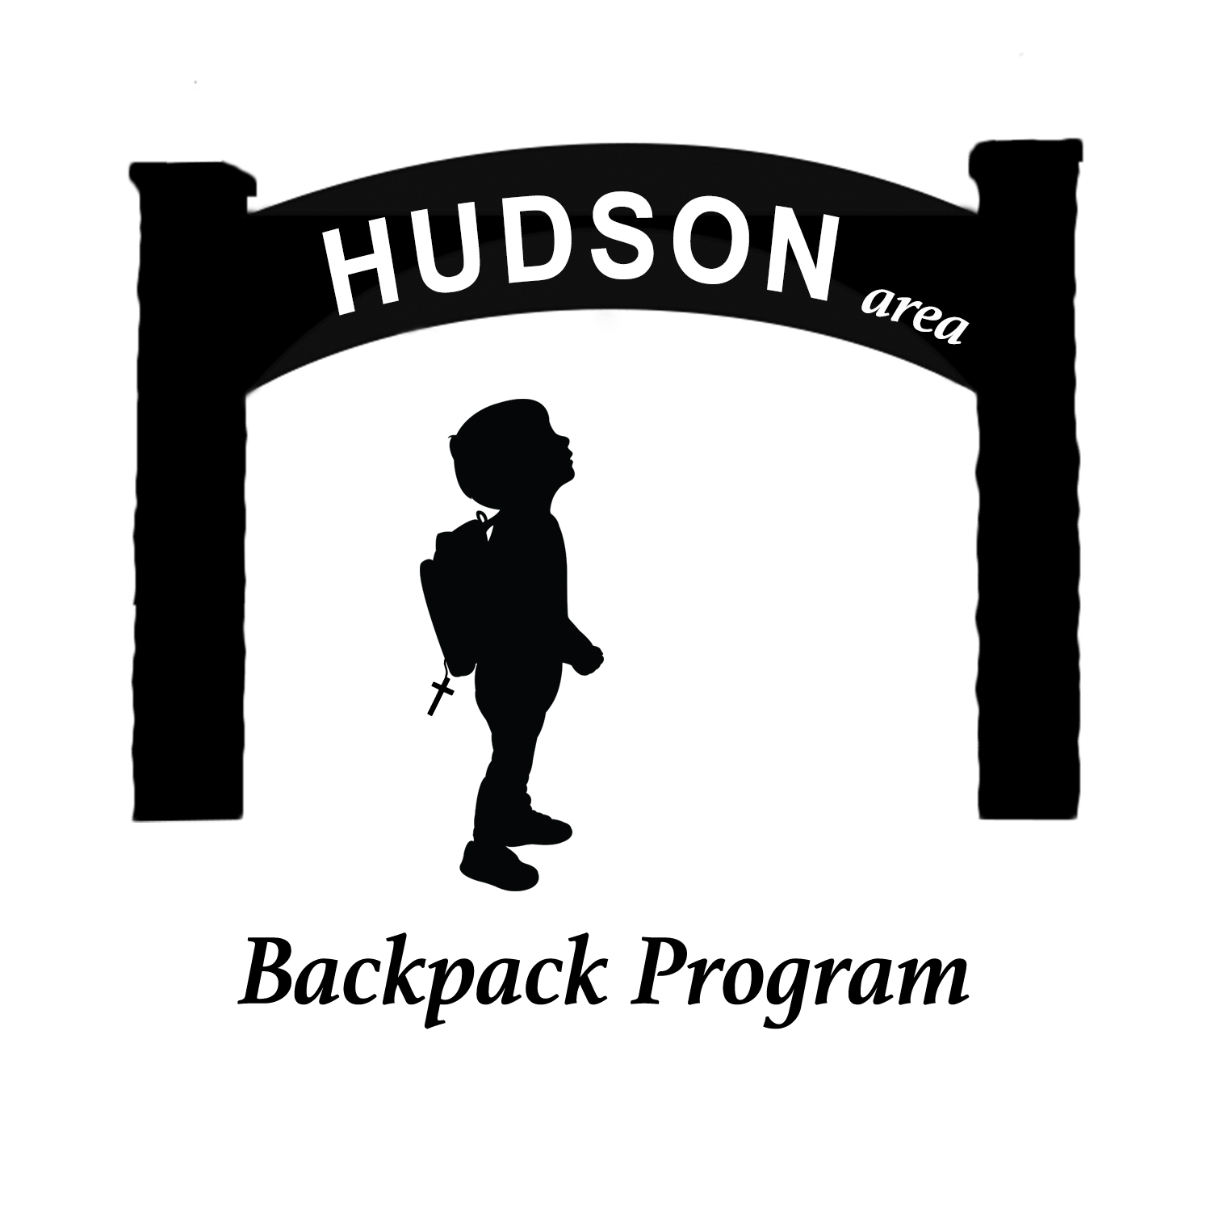
HUDSON BACKPACK PROGRAM REGISTRATION- 2019-2020
September 16, 2019
Dear Hudson School District Parent/ Guardian,
The Hudson Backpack program would like to offer families in need the opportunity to participate in our food support program. The program works closely with the Hudson School District, 10 local churches, and various clubs, businesses, and individuals to make this program possible.
- The program is confidential- only school officials will know your name.
- Every Thursday during the school year a backpack or cinch bag will be delivered to your child’s school filled with breakfast and dinner items to help cover food needs over weekends.
- Included in the packing twice a month will be a dated voucher valued at $18. The voucher may be used at Family Fresh Grocery for listed items. Please be sure to check the expiration date.
- Items that will be covered by the voucher are meat, fresh produce, bread, cheese, eggs, or milk. You decide how the voucher is to be used- $18 worth of meat, $10 for meat & $8 of produce- the choice is yours.
If you want to participate in the program please fill out the form below and return it to your school counselor by Friday, September 27. The first cinch bag distribution is on October 10. Calendars of distribution dates will be included with your first packing.
Participants- please cut and keep the note above for your information.
CUT**********************************CUT******************************CUT******
# # # # # # # COUNSELOR’S SECTION # # # # # #
Print parent/guardian name ___________________________________________________________
Signature of Parent/Guardian __________________________________________________________
Total number of family members in the household___________
Child taking the food bag home ___________________________________ ______________ who
attends _________________________________________________ School or 4K Daycare Center.

********* CUT ****** BACKPACK PROGRAM’S SECTION ************** CUT**********
Parents/Guardians please tell us the number of children at each level.
Number of children in Pre-K ______ Number of children in grades K through Grade 5 ______
Number in Middle School ____ Number in High School _____ Total number of family members _____
Cell phone number for occasional messages (OPTIONAL)_______________________________________

